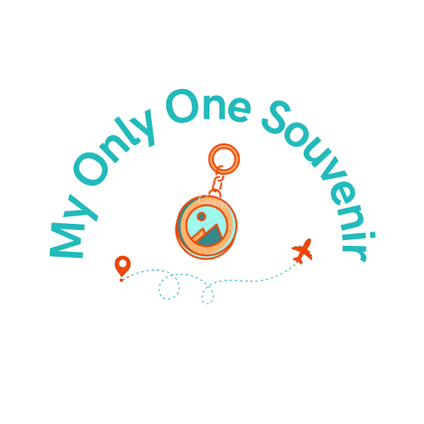

**My Only One Souvenir Website**

Emma Katherine Ribas Ludgero

WWD 130 – Web Fundamentals

July 19th, 2022

Subject

My personal site is about souvenirs. We have fantastic trips in our life, but we forget to memorize that forever. My idea is to sell souvenirs online, which are totally customized and represent the good moments of life. This site lets you know about my story, how to customize your souvenir, and how our logistic works in Brazil. I chose the name "My Only One Souvenir" because it feels something unique and personal. It gives an idea that only you have that souvenir. And that is what we do precisely! You can choose which type of souvenir you want, it may be a keychain, a framework, a mug, or whatever you imagine, and we will do our best to meet your expectations and give your Only One Souvenir!

Audience

My audience is basically travelers and dreamers. Anyone that wants to create a special memory can make it with us. Travelers may have forgotten to buy their souvenirs, or it was too expensive, but now they want and can do that through my website. Or dreamers wish to motivation and can make a souvenir. Anyone who dreams or travels will feel realized with my website.

URL:

<https://emmaludgero.github.io/wwd130/mysite/index.html>

or

[My Personal Site](https://emmaludgero.github.io/wwd130/mysite/index.html)

Goal

My primary goal is to accomplish every requirement and be successful in both HTML and CSS. I aim to feel comfortable working when I see an HTML file or a styling language. My objective on this site is to give the best I can and show that I can finish a project.

Design Process

At first, the site was horrible. I didn't understand many such things. But I focused on my studies and did my best! I believe my website is better than I thought. I imagined something simple, but now I can see I did something extraordinary. I would like to look more professional and original, but I'm learning with time, and I hope I can apply all of this in my job. Two significant changes were the color theme and the form request. With the new colors, things were natural and pretty. With the forms, I gave more content to my website and a way to interact with my customers. I thought of showing the souvenirs with prices in a separate box, but it would like impersonal. With the forms, I can show I really want to give something customized to my clients and that I care about their opinions. So, I believe this was a great website, and I'm proud of what it looks like.

Conclusion

With this project, I literally learned what HTML is in real life! The other assignments were accessible at all, but for this one, I had to think by myself and complete a site from zero. I learned so much, like the concepts and the functions in HTML, as well as my progress in accomplishing something. It was hard in the beginning. Sister Daley helped a lot! I'm so grateful for her! From every feedback of her, I could learn a lot. I build a website in every step, and I look forward to doing more. During these two weeks, I could see how I had already applied these skills in my job. I'm so content to see this happen. I can use my knowledge to help and improve my work. For example, today, I was helping in a campaign from Nestlé, and I had to check their HTML and understand what was wrong. I had to learn about HTML 4.0 Transitional and its rules. But all the structure I understood. That's why I loved this class and love my bachelor's degree.